
Volunteer Role – Arthurs Shed Session Lead

Aim: To deliver a weekly or fortnightly session to the public on a wellbeing-related topic or activity
Reporting to: Voluntary Services Manager
Shifts: Flexible, 1-1.5 hours per session plus set up and pack down time. Please ask to see the current schedule if your availability is very limited.
Will this role require a DBS check? No
Is there a minimum age requirement for this role? Age 17
Are reasonable expenses reimbursed? Yes, speak to the voluntary services team for more information

About Arthurs Shed
Arthurs Shed is beautiful garden studio set in the landscaped gardens of Arthur Rank Hospice. From here we run a range of workshops that are open to the public and free of charge, materials are also provided. These include physical activities such as chair fit or meditation classes, or wellbeing sessions such as arts and crafts. Most sessions last around 1-1.5 hours and welcome a diverse range of people, a very small number are patients, most are members of the public. The space seats around 8-10 people and all sessions are informal and relaxed and operate on a drop-in basis. The Shed allows the charity to raise awareness of its work by bringing people into the Hospice building who may not otherwise have visited us.

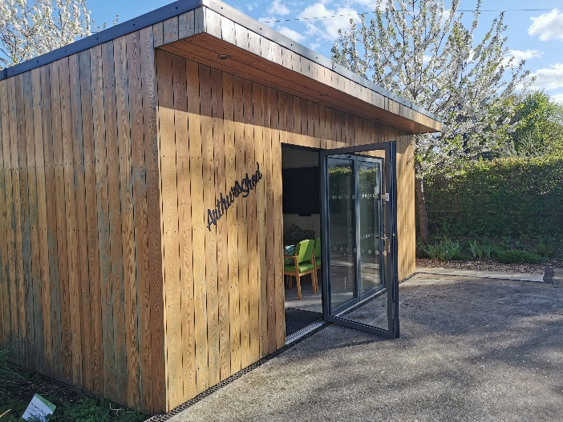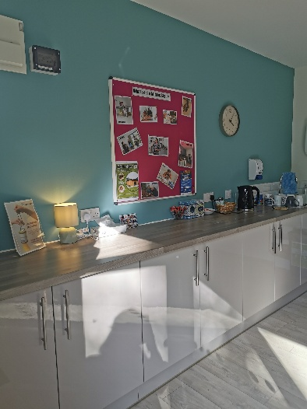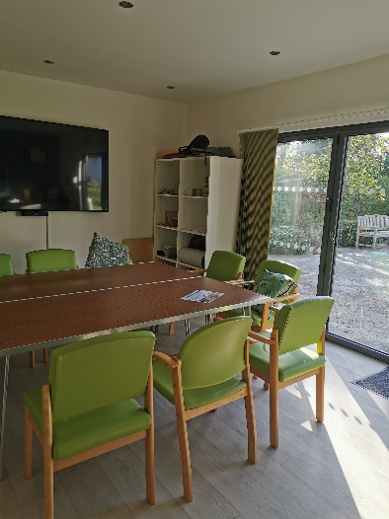

What you will be doing:
- Setting up and packing down the session
- Facilitating a session on a wellbeing related activity, you do not need to be qualified (unless this is applicable to the type of work) but you should be experienced enough to show others and support them
- Ensuring you complete the necessary paperwork and governance at each session including signing attendees in and out, requesting feedback forms and donations and general housekeeping
- Providing a warm and welcoming environment that helps people to feel ease

What will be expected of you:
A code of conduct will be available in your handbook, detailing expectations in full, these include:
- Attending shifts on time and alerting staff if you are unable to come in, with as much notice as possible
- Conducting yourself in line with our values at all times: Caring, Compassionate, Community and Excellence. Recognising when volunteering you are representing the Charity
- Maintaining strict confidentiality about those we support
- Ensuring you act in line with charity policies and guidance around safeguarding vulnerable adults and children

What you can expect from us:
An opportunity to:
- Make a difference to a local cause, supporting your community directly
- Meet new people and feel part of a team
- Develop new skills and experiences to add to your CV or University application
- Receive training, induction and ongoing support and supervision
- Reimbursement of reasonable expenses

Person Specification
We ask all of our volunteers to act in line with relevant policies and procedures and within the boundaries of their volunteering role, asking for support if they have queries or concerns. We also expect all volunteers to act in a way which demonstrates our values.
For this role in particular, we ask that you:
- Feel physically able to move the room around, set it up and pack it down as you need it
- Feel confident working proactively with no day-to-day supervision, seeking support where you need it (once you have been trained)
- Are comfortable working in a group setting and navigating different abilities
- Have an awareness of the diversity of people that join and treat everyone with respect, kindness and compassion

If you’re interested in this role, please email or phone our Volunteer Team at: volunteer@arhc.org.uk 01223 675872
Or apply online at: www.arhc.org.uk/join-us/volunteer-opportunities/

We are committed to inclusivity, respect, fairness, engagement and equality of opportunity for our patients and their families, our staff and trustees, our volunteers and our supporters. We value the strength that comes with difference and the positive contribution that diversity brings to our community.


Arthur Rank Hospice Charity is committed to safeguarding and promoting the welfare of children, young people and adults who draw on care and support and expects all colleagues and volunteers to share this commitment.

