**Volunteer Role – Driver**

**Aim:** To support those who cannot make their own way to the Hospice by driving them.

**Reporting to**: Living Well Service Team Lead & Administrator

**Shifts:** Tuesdays and Thursdays, ready at the Hospice for a 10:30am start, and to collect to take home at 1pm. You are welcome to wait at the Hospice Bistro or head home in between if you prefer

**Will this role require a DBS check**? Yes, enhanced *If you have a conviction and would like to discuss its implications with us ahead of applying, please do get in touch. Please note DBS checks are free to volunteers*

**Is there a minimum age requirement for this role?** Age 18, we also ask that you have been regularly driving for a minimum of 2 years

**Are reasonable expenses reimbursed?** Yes, speak to the voluntary services team for more information

**About the Living Well Service**

The Living Well Service offers a range of support on different days. Before a patient attends, we do a holistic assessment to find out which session will suit them best. We spend time discovering what is important to them and shape their goals together, which makes a real difference to their everyday life.

**Find out more here**: <https://www.arhc.org.uk/supporting-you/care-services/living-well/>

**What you will be doing:**

* To collect a patient from their home and bring them to their session at the Hospice and/or take them home at the end of their session.
* Provide a listening ear if the patient does wish to talk during the journey; not all do.
* Liaise with the patient regarding their journey beforehand to confirm they still wish to attend.
* 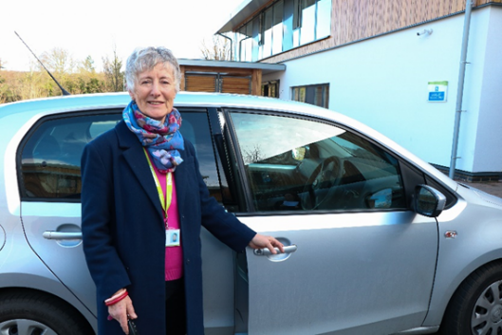Maintain your Drivers paperwork each year to confirm your suitability to drive and respond to requests for refreshed paperwork promptly.
* On occasion you may also be asked to drive those attending bereavement support or visiting a loved one on our in-patient unit.

*Patients are assessed for suitability by a member of staff before being allocated a volunteer Driver; those who are unsuitable are supported in accessing Hospital transport.

**What will be expected of you:**

A code of conduct will be available in your handbook, detailing expectations in full, these include:

* Attending shifts on time and alerting staff if you are unable to come in, with as much notice as possible
* Conducting yourself in line with our values at all times: Caring, Compassionate, Community and Excellence. Recognising when volunteering you are representing the Charity
* Maintaining strict confidentiality about those we support
* Ensuring you act in line with charity policies and guidance around safeguarding vulnerable adults and children

**What you can expect from us:**

An opportunity to:

* Make a difference to a *local* cause, supporting your community directly
* Meet new people and feel part of a team
* Develop new skills and experiences to add to your CV or University application
* Receive training, induction and ongoing support and supervision
* Reimbursement of reasonable expenses

**Person Specification**

We ask *all* of our volunteers to act in line with relevant policies and procedures and within the boundaries of their volunteering role, asking for support if they have queries or concerns. We also expect all volunteers to act in a way which demonstrates our values.

For this role in particular we ask that you:

* You must be able to drive, have access to a car and have no health conditions which may impact your suitability to drive
* You must remain professional at all times and maintain strict boundaries, understanding your role is different to a friend and recognising the need to be patient-led in your conversations
* You must be able to make a regular weekly commitment as we aim to provide each patient with the same Driver for the duration of their 8-10 sessions for Tuesday and Thursday patients.

If you’re interested in this role, please email or phone our Volunteer Team at: [volunteer@arhc.org.uk](mailto:volunteer@arhc.org.uk)

01223 675872

Or apply online at: [www.arhc.org.uk/join-us/volunteer-opportunities/](http://www.arhc.org.uk/join-us/volunteer-opportunities/)

*We are committed to inclusivity, respect, fairness, engagement and equality of opportunity for our patients and their families, our staff and trustees, our volunteers and our supporters. We value the strength that comes with difference and the positive contribution that diversity brings to our community.*

*Arthur Rank Hospice Charity is committed to safeguarding and promoting the welfare of children, young people and adults who draw on care and support and expects all colleagues and volunteers to share this commitment.*