Role – Alan Hudson Day Treatment Centre
Volunteer Head Gardener

Arthur Rank Hospice Charity is committed to inclusivity, respect, fairness, engagement and equality of opportunity for our patients and their families, our staff and trustees, our volunteers and our supporters. We value the strength that comes with difference and the positive contribution that diversity brings to our community.
Would you like to apply for this role?
Go to https://www.arhc.org.uk/join-us/volunteer-opportunities/, click ‘Apply Now’

Aim: To support the Centre by advising on planting and how best to maintain its gardens
Reporting to: Matron
Shifts: Varied and flexible hours, approximate commitment of a few hours per month
Will this role require a DBS check? No
Is there a minimum age requirement for this role? 17

About the Alan Hudson Day Treatment Centre
Our multi-disciplinary team of highly qualified staff and dedicated volunteers provide expert care, which is holistic and tailored to each person’s specific needs. Services include Living Well, treatment and clinical days (including blood transfusions, oncology and symptom management), complementary and diversional therapies, and bereavement and support services. The Centre also supports people in the community. The Centres garden was expertly redeveloped in 2021 and requires support to keep it looking beautiful for our patients!

To find out more about the Centre go to: https://www.arhc.org.uk/supporting-you/care-services/alan-hudson-day-treatment-centre/

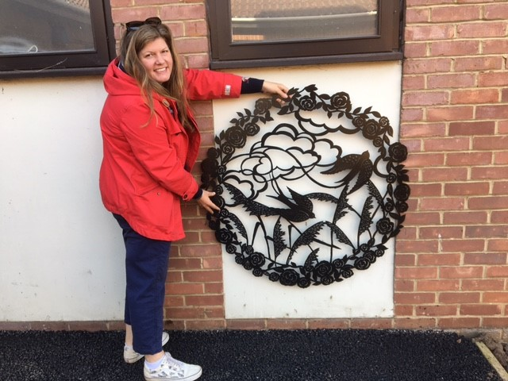

Main Responsibilities
- Advising the Team on how best to maintain the gardens including planting, pruning, weeding and garden development.

General Responsibilities
- Telephone the Centre as soon as possible if unable to fulfil your commitment
- Always maintain strict confidentiality
- To support the Charity in its aims and missions
- Attend or contribute to volunteer meetings whenever possible
- To adhere to the Volunteer policies and procedures set out in your training and induction

Benefits of volunteering in this role
- An opportunity to make a difference and support your local community
- Develop new skills and experiences to add to your CV or University application
- An opportunity to be part of a professional team and contribute to a very worthwhile cause
- Training and induction relevant to the role
- Reasonable out of pocket expenses will be reimbursed

Person Specification
Applicable to all roles | Role Specific
To be non-judgemental, kind and compassionate in all your interactions | Experience of garden work
To ensure you maintain confidentiality | Comfortable to work proactively with minimal supervision
To adhere to the boundaries of a volunteer role | Own tools if practical work to be carried out
To be proactive in seeking support or supervision when needed

If you’re interested, please email or phone our Volunteer Team at: volunteer@arhc.org.uk
01223 675872

