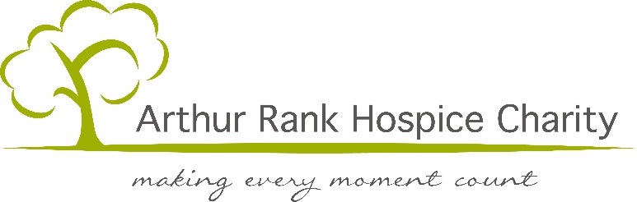

TCS London Marathon 2023
Golden Bond application

We are fortunate enough to have Charity (Golden Bond) Places for the TCS London Marathon 2023. The Charity asks successful applicants to commit to raise £1500. If you would like to register your interest in running for Arthur Rank Hospice Charity please complete the form below and return to Freepost ARTHUR RANK HOSPICE CHARITY (this address is complete) or email challenges@arhc.org.uk no later than 12noon on 17th October 2022.

Applicant Details
Title: First Name: Surname:
Address:

Email Address:
Contact Telephone Number:
Date of Birth:
Did you apply for a ballot place? Yes / No
Name of Company/Employer:
Do they offer matched funding? Yes / No

Do you have a particular connection with Arthur Rank Hospice Charity? If so, please give details below.

In return for a Golden Bond Charity place, we ask that you commit to raise £1500 for the Charity but you can choose to increase this if you wish. Please use the section below to give details of your fundraising plan and how you expect to reach your target. Include a breakdown of fundraising elements such as sponsorship and fundraising event ideas. In the past, challengers have organised a range of activities including spinathons, supermarket bag packing and collections, quiz nights and food related events.

Please give details of any running/fitness experience in the last three years (for example, how many times a week do you exercise, what kind of exercise do you do, distance covered, what running event experience do you have or anything else that you think is relevant):

Please continue onto a separate page if necessary.

APPLICATIONS RECEIVED AFTER 17th October 2022 WILL NOT BE CONSIDERED.

